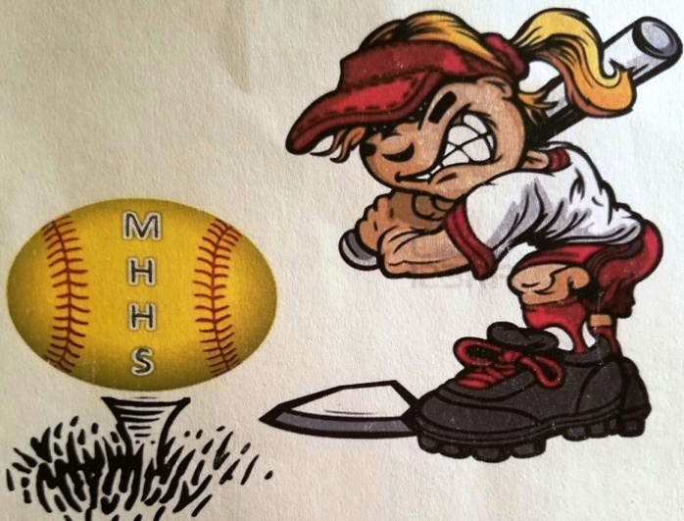
6th Annual Grizzly Golf Scramble
Friday,
April 6th

Dear Business Owner and Valued Supporter,

MHHS Booster Club is hosting our 6th Annual Grizzly Golf Scramble at Twin Oaks Golf Club in San Marcos. In conjunction with the Golf Scramble, we will be selling Raffle Tickets for donated Items at our Dinner. This is a great way to advertise your business as well as support our Mission Hills Girl’s Softball Athletes. Any type of Donation is very helpful to our organization.

All Donations are tax deductible:
GBEF Softball Tax ID # 46-3960523

MHHS Girls Softball Booster Club would like to THANK YOU for your contribution in raising funds for our growing program.

If you have any questions, Contact:
Golf Chair Jeremy @ 760 270 0070
Treasurer Jo-Anita @ 760 525 5263
Coach Franks @ Chad.franks@smusd.org

